MATH 6 | NAME:
ASSIGNMENT | DATE:
MATCH THE FOLLOWING EQUIVALENTS:
Mixed Numbers
VS.
Improper Fraction

11/5 | 1 6/8
16/3 | 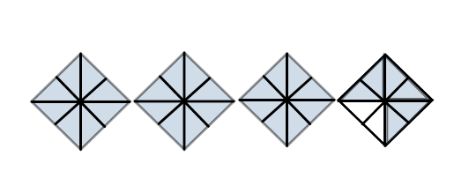
14/8 | 54 1/3
3/2 | 1 1/3
30/8 | 4 1/3
4/3 | 2 1/5
13/3 | 5 1/3
55/3 | 1 ½
Order from least to greatest
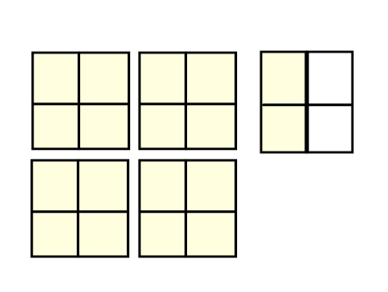
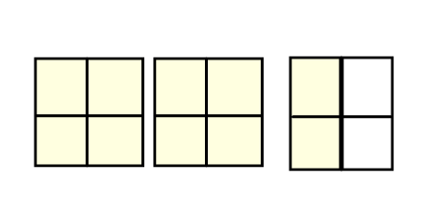
Write the answers below:
L)
K)
11/4
J)
I)
H)
G)
F)
E)
D)
C)
B)
A)
7/4
11/9
12 ¼
13/6
3 3/8
7 ½
23/4
15 ¾
5 ¾

